What is Child Abuse & Neglect?  Child Abuse: Words and/or actions that cause harm, potential harm, or threat of harm.  Child Neglect: Failure to provide a child’s basic physical, emotional or educational needs.  Types of Abuse:  - Physical Abuse  - Sexual Abuse  - Verbal Abuse  - Psychological/Emotional Abuse  Types of Neglect:  - Physical Neglect  - Emotional Neglect  - Medical and Dental Neglect  - Educational Neglect  - Inadequate Supervision  - Exposure to Violent Environments | Resources for Parents  www.erinslaw.org  R.A.I.N.N.  Rape Abuse Incest National Network Hotline  1-800-656-4663 (HOPE)  Childhelp National Child Abuse Hotline  1-800-4-A-CHILD  (800-422-4453)  Mutual Ground  418 Oak Ave.  Aurora, IL 60586  630-897-0084 | Erin’s Law  - Information for Parents  - 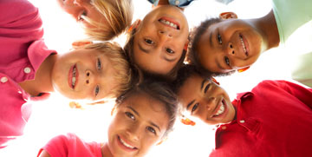  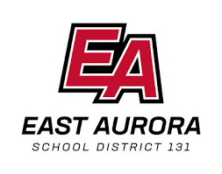

What is Erin’s Law?  “Erin’s Law” requires that all public schools in Illinois implement a prevention-oriented child sexual abuse program.  How will D131 address Erin’s Law?  In District 131, all students, from Pre-K to 12th grade, will be provided with a developmentally appropriate personal body safety program in their classroom. | STATISTICS  *1 in 6 boys and 1 in 4 girls are sexually abused before the age of 18  *1 in 7 children have experienced abuse or neglect in the last year  *1 in 5 children are solicited sexually over the internet by the age of 18  *90% of children personally know their abusers  *95% of child sexual abuse can be prevented through education  *https://www.cdc.gov/violenceprevention/childabuseandneglect/index.html  What’s in the Erin’s Law Program?  - Distinguishing between safe and unsafe touches.  - Learning this simple safety rule: No One Should Touch your Private Parts except to keep you clean and healthy.  - Informing the students of what do if someone breaks this rule:  - Say “No!”  - Get Away.  - TELL A TRUSTED ADULT!  (most important) | Possible Warning Signs:  - Nightmares/Trouble sleeping/Bed wetting  - Change in appetite  - Fear of certain people, places or activities  - Depression  - Aggression  - Feeling shameful or guilty  - Isolating oneself  - Withdrawal from someone  - Resisting removing clothes when appropriate times (bedtime, bath time)  - Change in academics  - Running away from home  - Suicidal thoughts  - Acting out sexually  - Exhibits adult sexual behaviors, knowledge, and language  - Eating Disorders  - Self-Injury  - Drug and Alcohol Abuse  - Promiscuity (in adolescence)  Do you have Concerns?  If you notice a change in your child’s behavior, have concerns or would like additional information, please contact your child’s school.

